- \Operation\Tube filling – blow-off filling\Blow-off filling
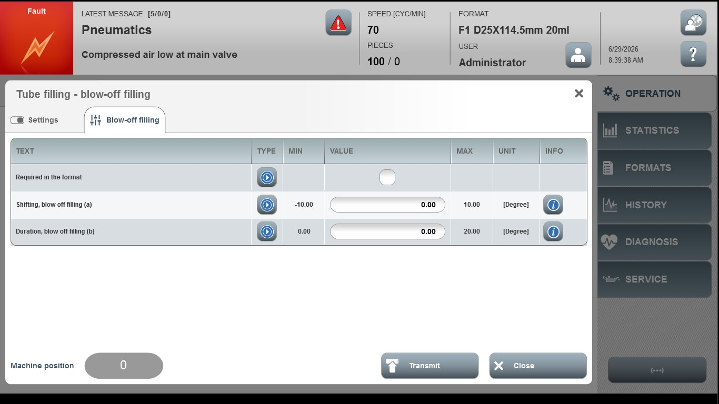
Acceptance criterion | Limits | Pass / Fail: Dev-No. | Date | Initials
Screen matches screenshot | N / A
Shifting, blow off filling (a) | -10.00 … 10.00
Duration, blow off filling (b) | 0.00 … 20.00

